Understandings, Applications and Skills (This is what you maybe assessed on)

 | Statement | Guidance
1.6.U1 | Mitosis is division of the nucleus into two genetically identical daughter nuclei. | The sequence of events in the four phases of mitosis should be known. To avoid confusion in terminology, teachers are encouraged to refer to the two parts of a chromosome as sister chromatids, while they are attached to each other by a centromere in the early stages of mitosis. From anaphase onwards, when sister chromatids have separated to form individual structures, they should be referred to as chromosomes.
1.6.U2 | Chromosomes condense by supercoiling during mitosis.
1.6.U3 | Cytokinesis occurs after mitosis and is different in plant and animal cells.
1.6.U4 | Interphase is a very active phase of the cell cycle with many processes occurring in the nucleus and cytoplasm.
1.6.U5 | Cyclins are involved in the control of the cell cycle.
1.6.U6 | Mutagens, oncogenes and metastasis are involved in the development of primary and secondary tumours.
1.6.A1 | The correlation between smoking and incidence of cancers.
1.6.S1 | Identification of phases of mitosis in cells viewed with a microscope or in a micrograph. | Preparation of temporary mounts of root squashes is recommended but phases in mitosis can also be viewed using permanent slides.
1.6.S2 | Determination of a mitotic index from a micrograph.

Recommended resources:
http://bioknowledgy.weebly.com/16-cell-division.html
Allott, Andrew. Biology: Course Companion. S.l.: Oxford UP, 2014. Print.

1.6.U4 Interphase is a very active phase of the cell cycle with many processes occurring in the nucleus and cytoplasm.

- Define the following:

Cell cycle | All stages in the life cycle of a cell.
Interphase
Mitosis
Cytokinesis
Apoptosis
Necrosis
Diploid
Haploid

- Outline the stages of interphase.

Stage | Events

- List three metabolic reactions that occur during interphase.

1.6.U2 Chromosomes condense by supercoiling during mitosis.

- Explain why cells need to supercoil their DNA molecules.

- Outline how DNA molecules are supercoiled.

N.B. A key point to remember is that supercoiling prevents DNA from being transcribed into messenger RNA. [link to 2.7.U4]

1.6.U1 Mitosis is division of the nucleus into two genetically identical daughter nuclei.

- Distinguish between cell division and mitosis.

- Other than maintaining optimum cell size, list four processes involving division by mitosis.

- Explain why eukaryotes need to use mitosis in cell division when prokaryotes do not.

- Identify the outcome of one division by mitosis.
 | Number of daughter cells | Nucleus
 | 2 | Haploid
 | 2 | Diploid
 | 4 | Haploid
 | 4 | Diploid

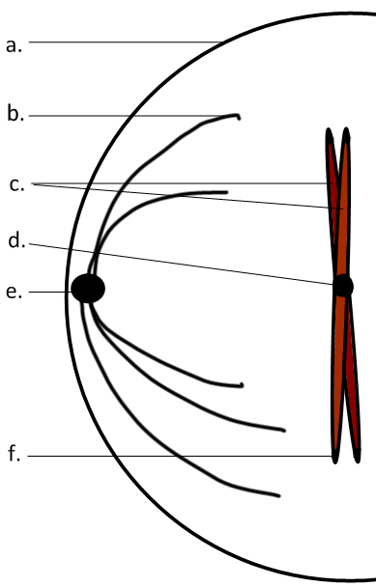
- Label the diagram.

a | plasma membrane
b
c
d
e
f | telomeres

- Distinguish between chromosomes and chromatids.

- Outline the stages of mitosis of an animal cell with a chromosome number of four.

 | Diagram | Outline
Prophase | 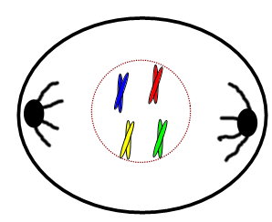
Metaphase
Anaphase
Telophase

- Explain how mitosis leads to two genetically identical nuclei.

Sister chromatids
S-phase
DNA Replication | Semi-conservative, complementary base-pairing results in fewer mistakes and copies of all genes in all new chromosomes.
Metaphase
Anaphase

1.6.U3 Cytokinesis occurs after mitosis and is different in plant and animal cells.

- Distinguish between mitosis and cytokinesis.

- Outline cytokinesis in plant and animal cells

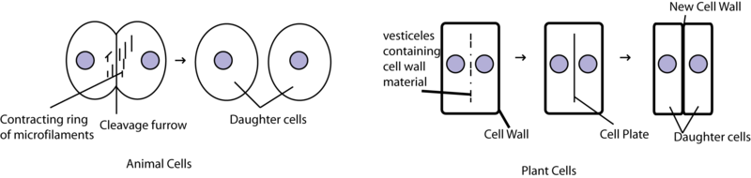
http://upload.wikimedia.org/wikibooks/en/thumb/9/98/Cyto.png/800px-Cyto.png
Animal cells | Plant cells

1.6.U5 Cyclins are involved in the control of the cell cycle.

- Draw and label a pie chart to show the relative amount of time spent in each phase of the cell cycle, including the stages of interphase and mitosis, as well as cytokinesis.

- Define the term cyclin:

- Explain how cyclins affect control the progression of a cell through the cell cycle.

- Outline the roles of the four cyclins involved in control of the cell cycle:

Function
Cyclin A
Cyclin B
Cyclin D
Cyclin E

- The graph shows the concentrations of the four main cyclins at different points in the cell cyle. Label the graph to identify which line represents of the four main cyclins outlined above.

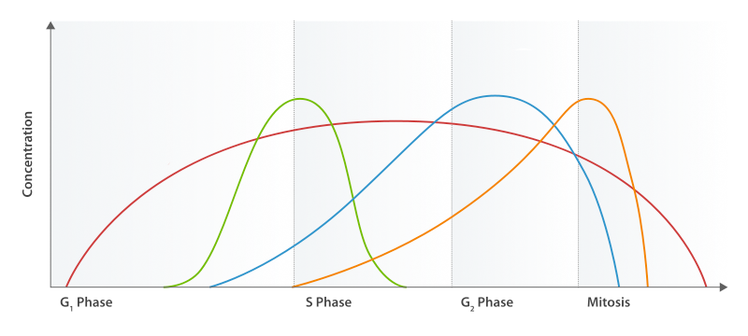
adapted from: http://upload.wikimedia.org/wikipedia/commons/thumb/c/ce/Cyclin_Expression.svg/800px-Cyclin_Expression.svg.png

1.6.S1 Identification of phases of mitosis in cells viewed with a microscope or in a micrograph.

- Label the micrograph to identify at least one example of a cell in each phase of mitosis.
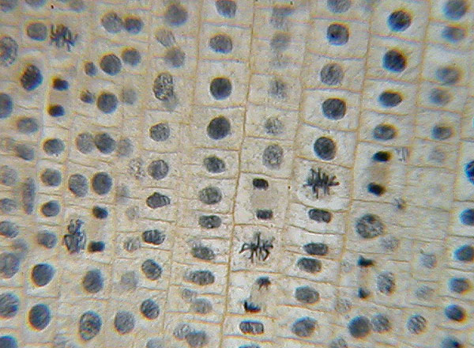
http://cnx.org/resources/4035aea2d706510a12ec779a06dd68dd/graphics51.jpg

1.6.S2 Determination of a mitotic index from a micrograph.

Micrograph of a pressed onion root meristem
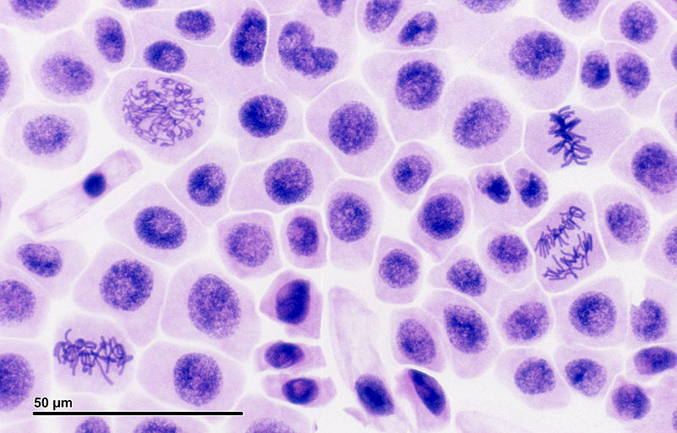
http://upload.wikimedia.org/wikipedia/commons/e/e3/Mitosis_%28261_13%29_Pressed%3B_root_meristem_of_onion_%28cells_in_prophase,_metaphase,_anaphase,_telophase%29.jpg

- Complete the table by classifying each cell (do not count cells wholly in the image) based on what phase of the cell cycle it is in.
 | Interphase | Mitosis
 |  | Prophase | Metaphase | Anaphase | Telophase | Total
Number of cells | 46 | 1 | 2 | 1 | 3
%

- Using the table state the mitotic index of the above micrograph?

1.6.U6 Mutagens, oncogenes and metastasis are involved in the development of primary and secondary tumours.

- Define the term tumour.

- Cancer (also known as a malignant tumor) is a group of diseases involving abnormal cell growth with the potential to invade or spread to other parts of the body. List the names of four common types of cancer:

- Outline a primary tumour, metastasis and it’s development into secondary tumours.

- A mutation is a change in an organisms genetic code. A mutation/change in the base sequence of a certain genes can result in cancer.

  - What is the name given to the few genes that can become cancerous after mutating?

  - What role do these genes have in normal, healthy cells?

  - Explain briefly why a mutation in these genes could result in a cancer.

- Mutagens are agents that cause gene mutations. Not all mutations result in cancers, but anything that causes a mutation has the potential to cause a cancer.
  - State the collective name given to chemicals that cause mutations.

  - Give examples of non-chemical mutagens

- Several mutations must occur in the same cell for it to become a tumour causing cell. The probability of this happening in a single cell is extremely small. What factors (other than exposure to mutagens) increase the probability of tumour development in humans?

1.6.A1 The correlation between smoking and incidence of cancers.

- The graph below plots cigarette consumption and lung cancer deaths over time.
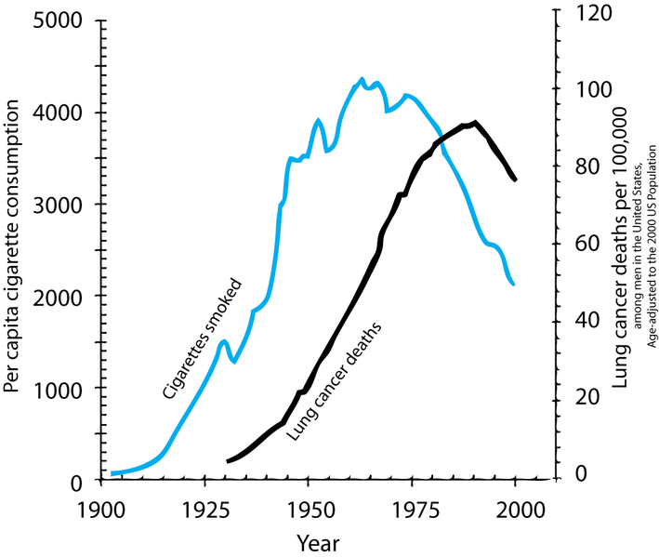
http://en.wikipedia.org/wiki/File:Smoking_lung_cancer.png

  - Describe the relationship shown.

  - What type of correlation is shown?

  - How strong is the correlation? Justify your answer by discussing the evidence.

  - The correlation shown here is lagged. A lag is a time gap between the factors. Estimate the size of the lag between cigarette consumption and lung cancer death.

- There are many other similar survey in different countries, with different demographics that show similar results. Along with lung cancer, cancers of mouth and throat are very common as these areas are in direct contact with the smoke too. List out 6 examples of other cancers that are more common in smokers than non-smokers.

- Correlation does not equal causation. Outline the direct evidence shows that it is tobacco smoke that causes the increased incidence of these cancers.

Citations:
Allott, Andrew. Biology: Course Companion. S.l.: Oxford UP, 2014. Print.

Taylor, Stephen. "Essential Biology 02.5 Cell Division.docx." Web. 24 Aug. 2014. <https://www.box.net/shared/3yh5839dua>.

